**FULL STACK DEVELOPMENT WITH MERN**

**Project Documentation**

## 1. Introduction

* Project Title: Flight Booking System (MERN)
* Team Members:
  + Santhosh – Full Stack Developer

## 2. Project Overview

**Purpose:**

The Flight Booking System allows users to search, book, and manage flight reservations. Admins can create and manage flight records.

**Key Features:**

* User Authentication (JWT)
* Search Flights
* Book Flights
* Admin Flight Management
* User Booking History

## 3. Architecture

**Caching (Redis):**

* Redis is used as an in-memory cache to improve performance.
* Cached data reduces MongoDB load and improves response speed.

**Docker:**

* Redis is containerized using Docker for easy deployment.

**Frontend (React):**

* Built using React + Axios for API calls.
* JWT-based protected routes.

**Backend (Node.js + Express):**

* MVC architecture
* Routes for auth, flights, bookings
* Middleware for authentication and admin role check

**Database (MongoDB):**

Collections:

* Users
* Flights
* Bookings

## 4. Setup Instructions

### Environment Variables (.env):

PORT=5000

NODE_ENV=development

MONGODB_URL=mongodb://localhost:27017/flightBookingDB

REDIS_URL=redis://localhost:6379

RATE_LIMIT_WINDOW_MS=900000 # in milliseconds

RATE_LIMIT_MAX_REQUEST=100

DEFAULT_EXPIRATION=900

CORS_ORIGIN=http://localhost:5173

JWT_SECRET=your_jwt_secret

PASSWORD_SECRET=my_password_secret

SALT_ROUNDS=10

ACCESS_TOKEN_EXPIRY=5m

REFRESH_TOKEN_EXPIRY=7d

COOKIE_EXPIRY=604800000 # in milliseconds

Run Redis using Docker**:**

docker run --name flight-redis -p 6379:6379 -d redis

## 5. Folder Structure

client/

src/

components/

pages/

services/

server/

controllers/

routes/

models/

middlewares/

## 6. Running the Application

**Backend:** npm start

**Frontend:** npm start

## 7. API Documentation

**AUTH:**

POST /api/auth/register

POST /api/auth/login

**FLIGHTS:**

GET /api/flights

POST /api/flights (Admin)

**BOOKINGS:**

POST /api/bookings

GET /api/bookings/user

## 8. Authentication

* Refresh token stored in HttpOnly cookie
* Access token sent in JSON response
* Refresh endpoint issues new access token

## 9. User Interface

(Screenshots to be added)

## 10. Testing

* Manual testing using Postman

## 11. Screenshots or Demo

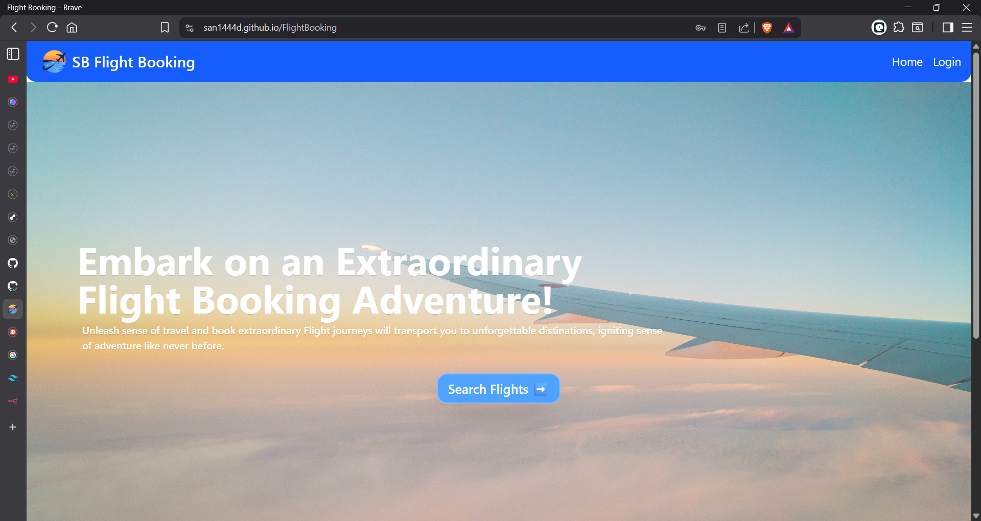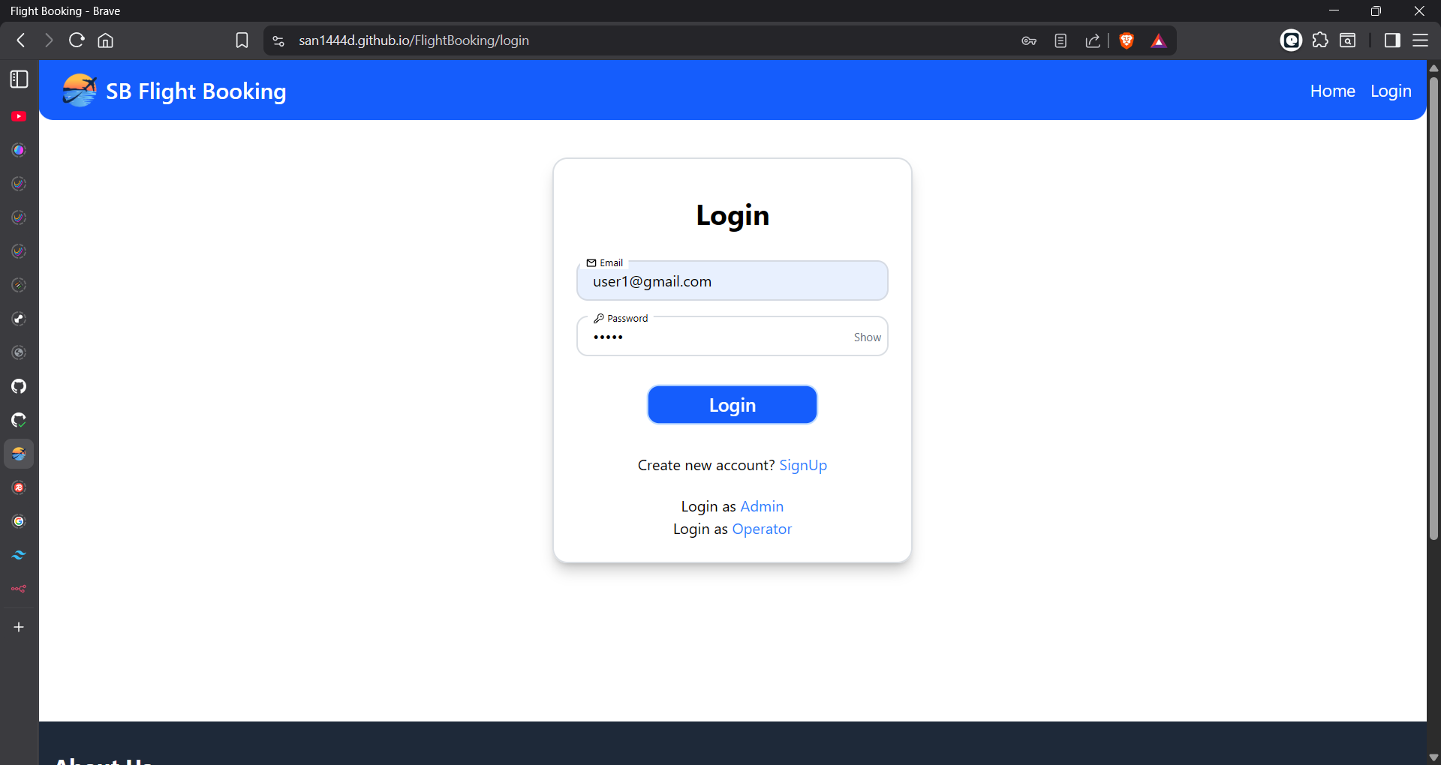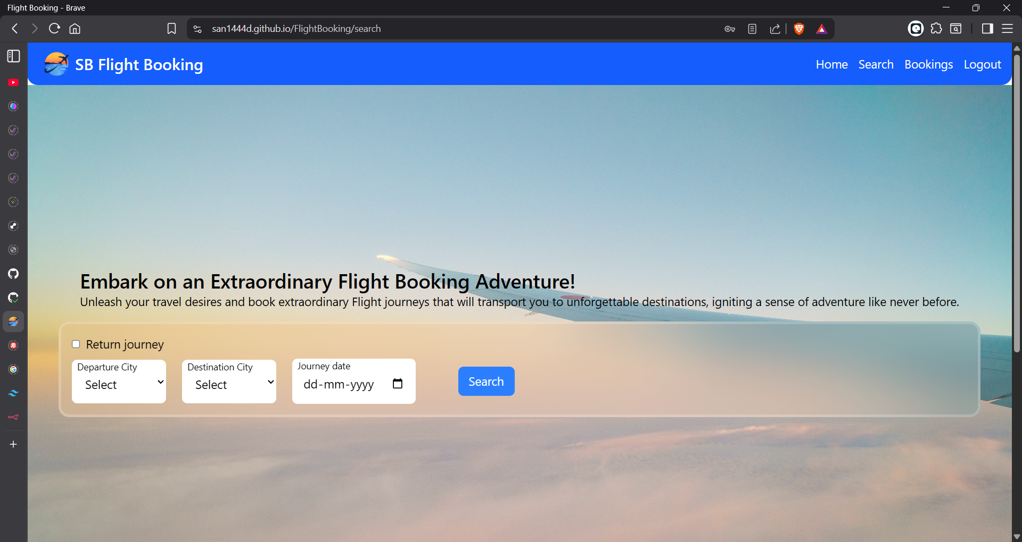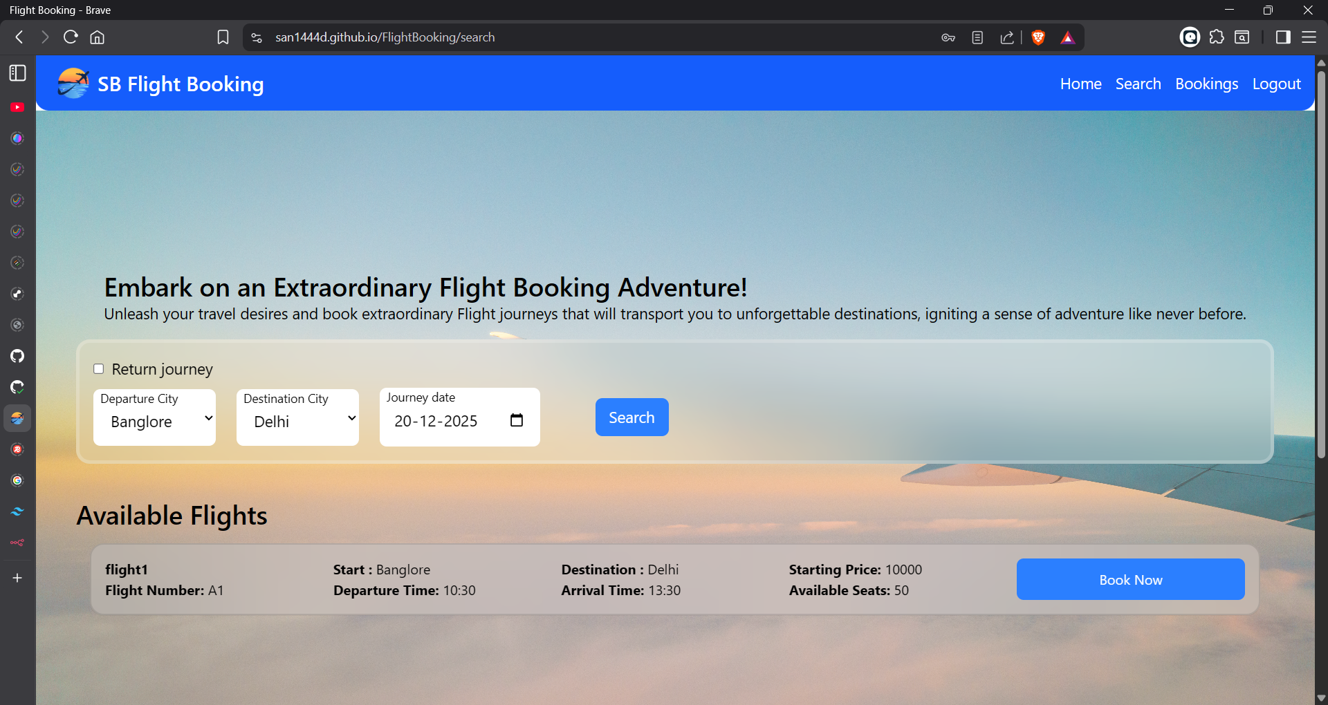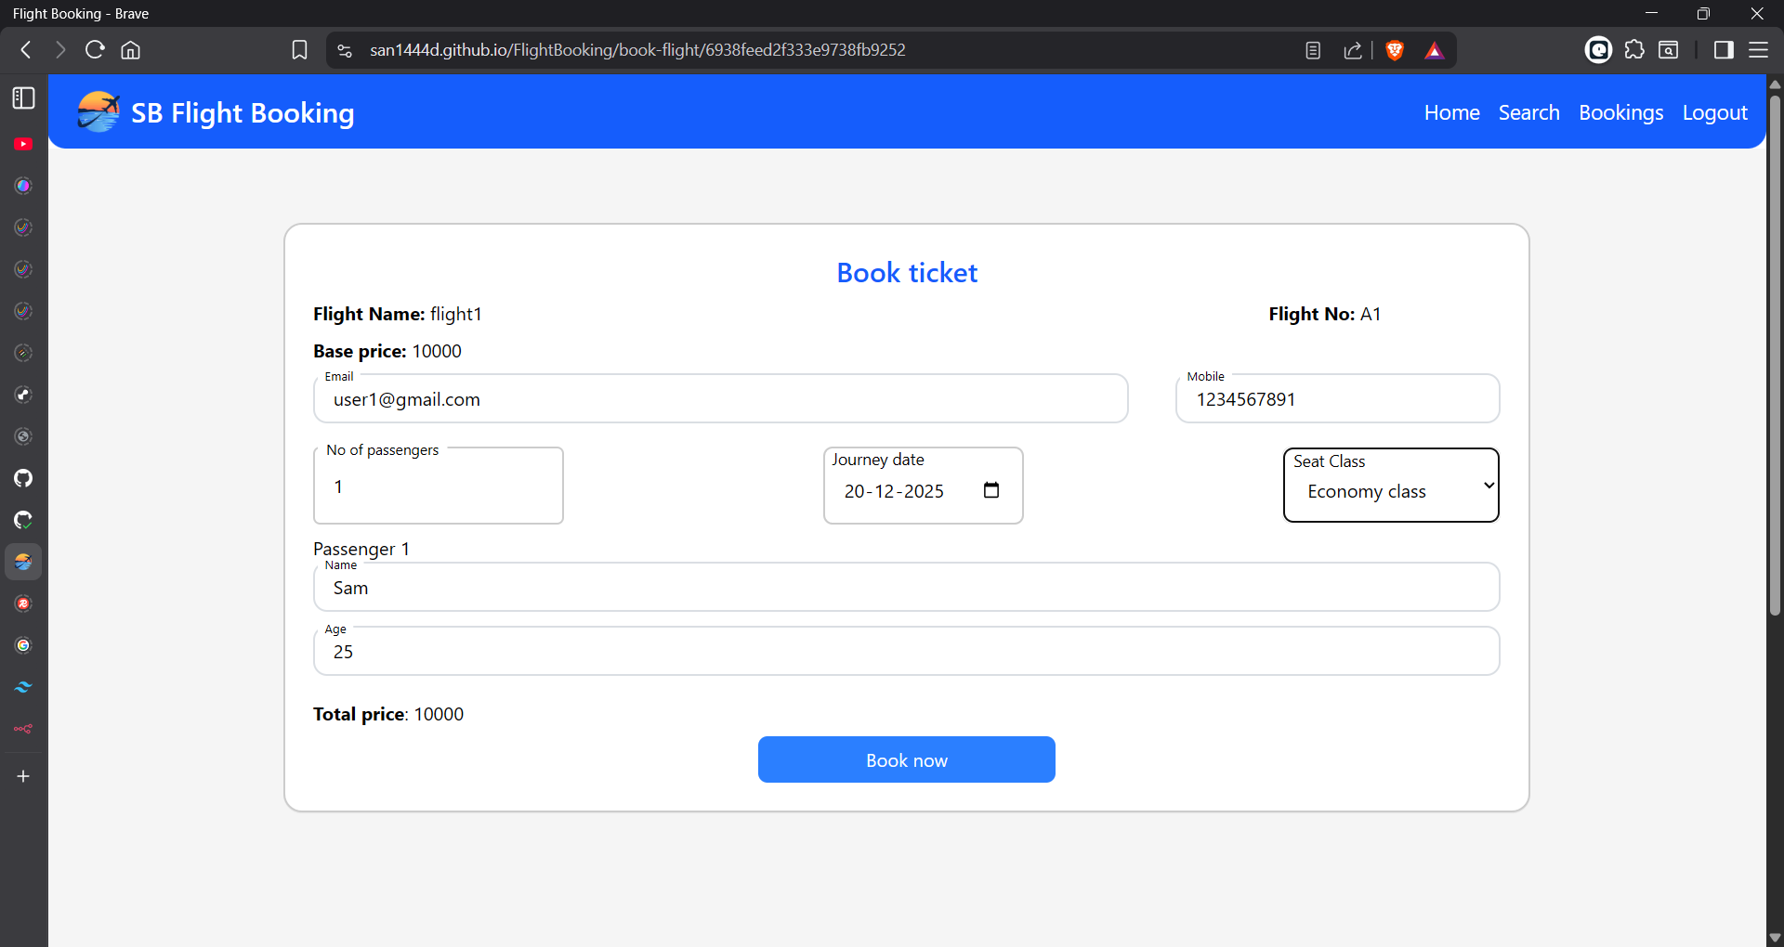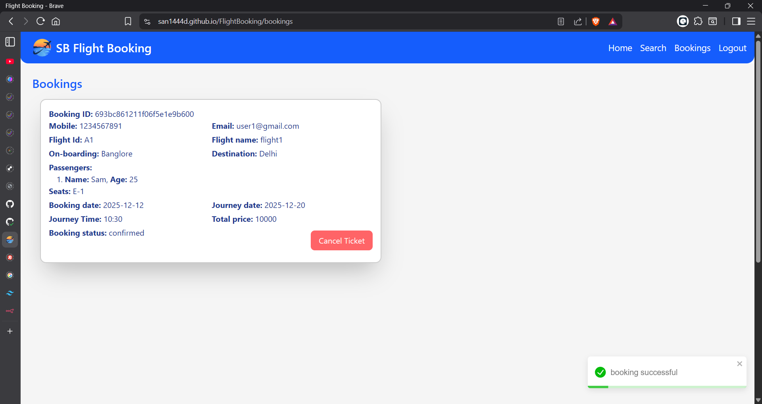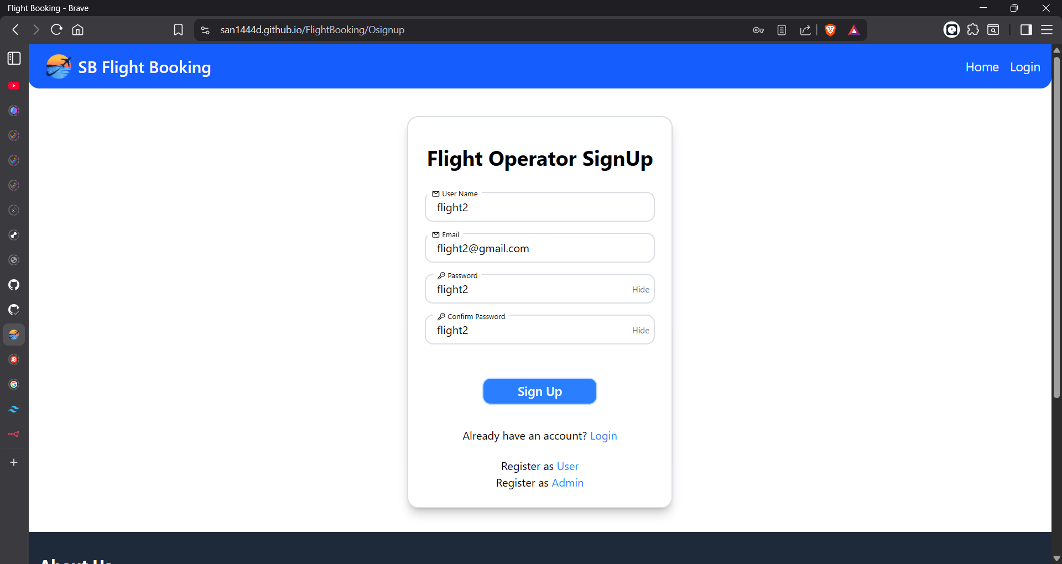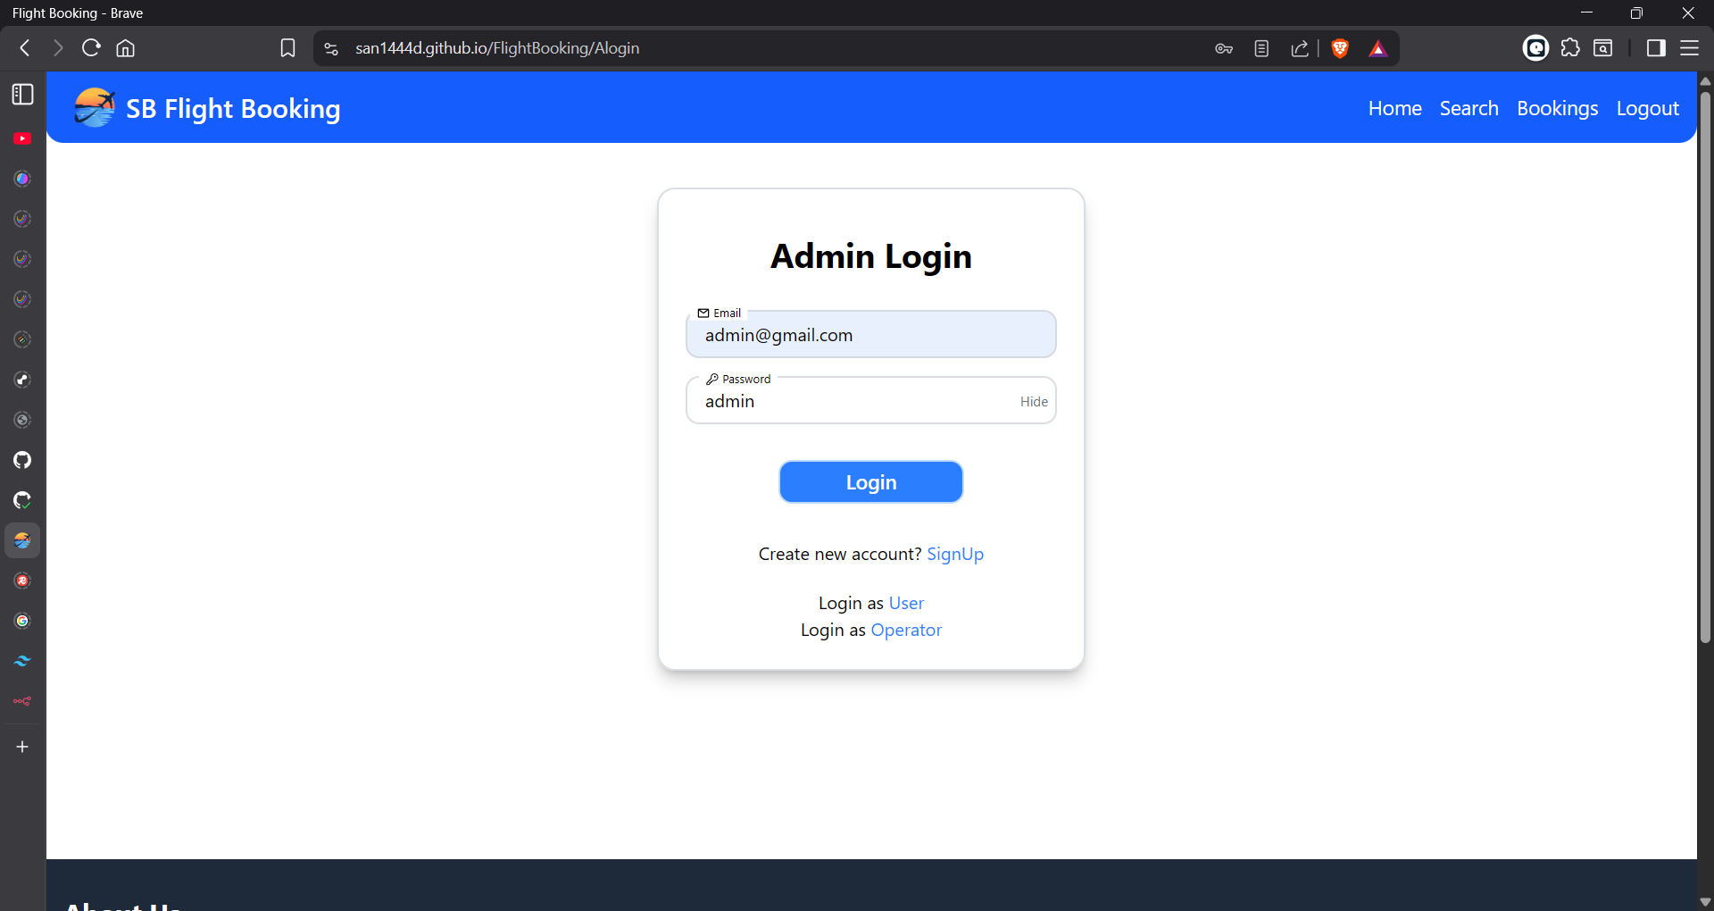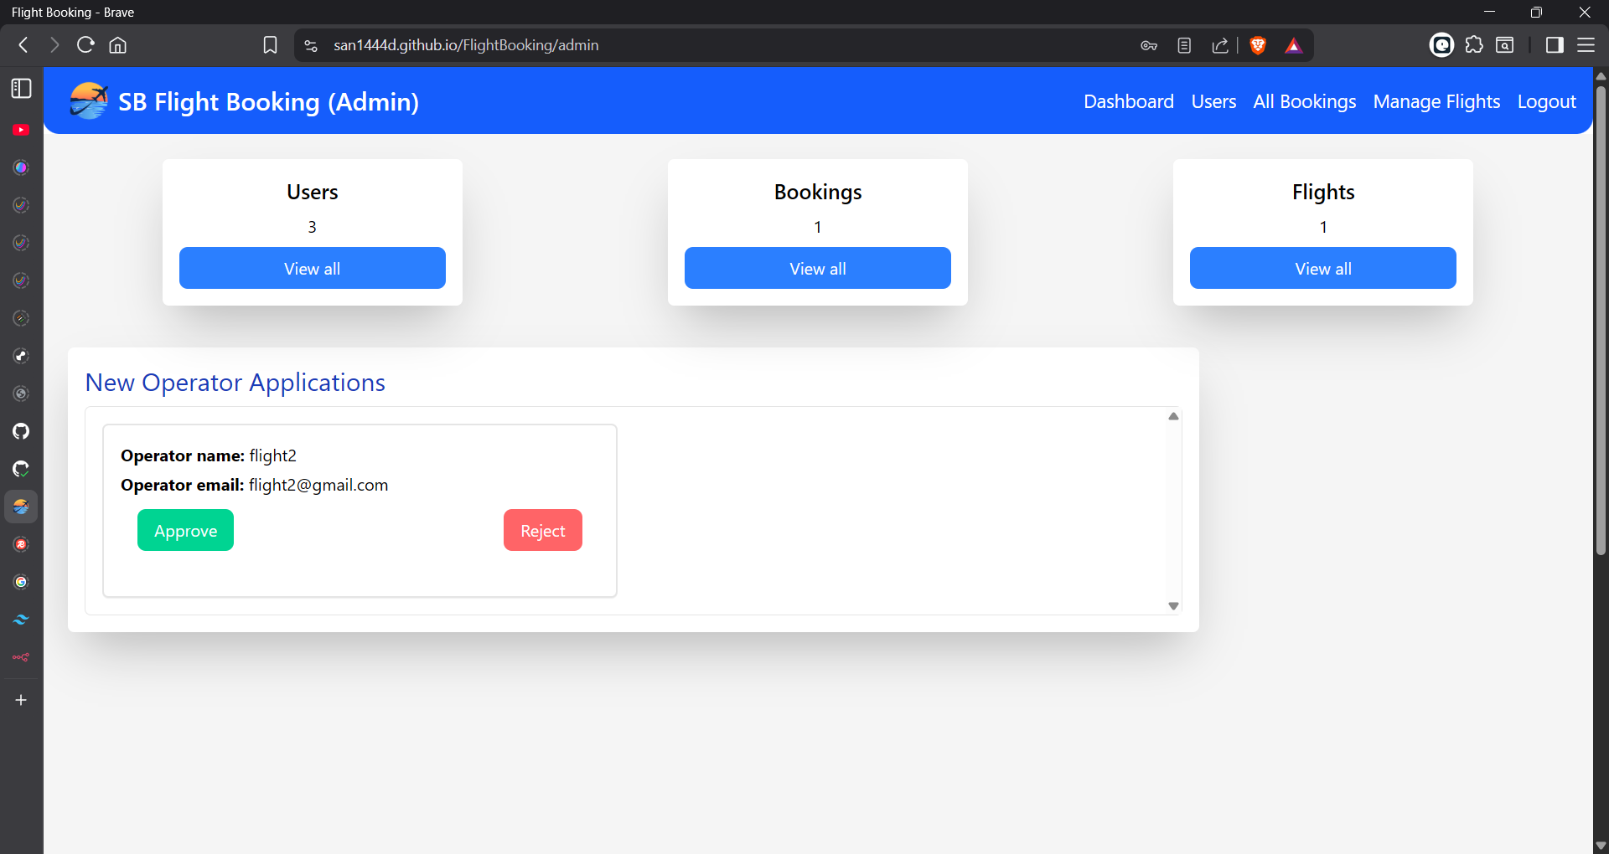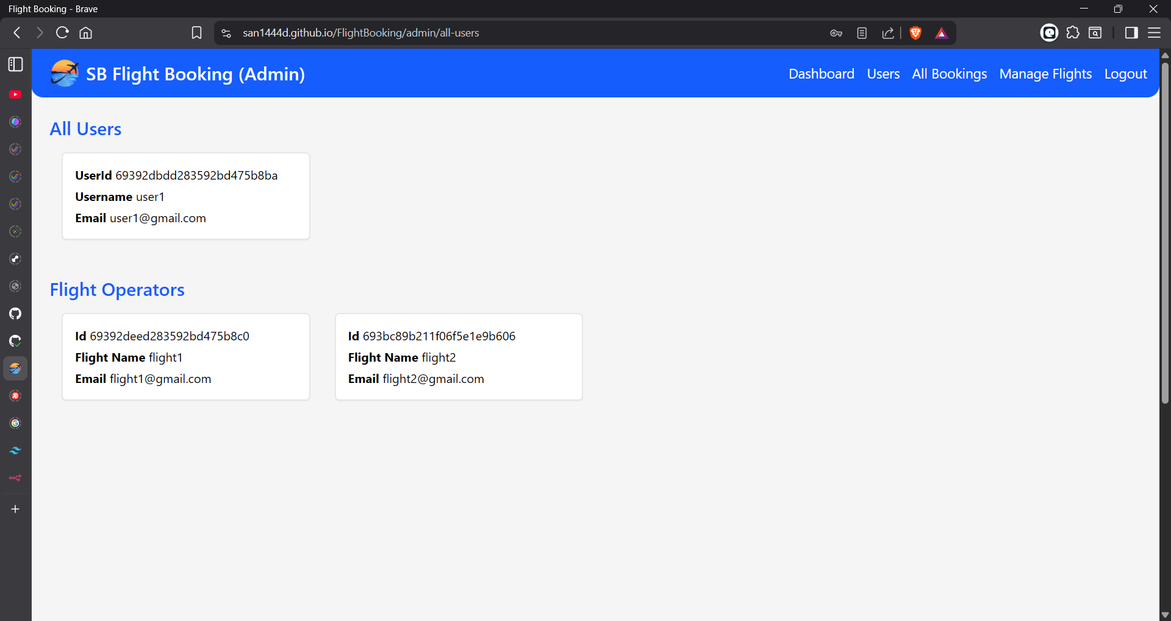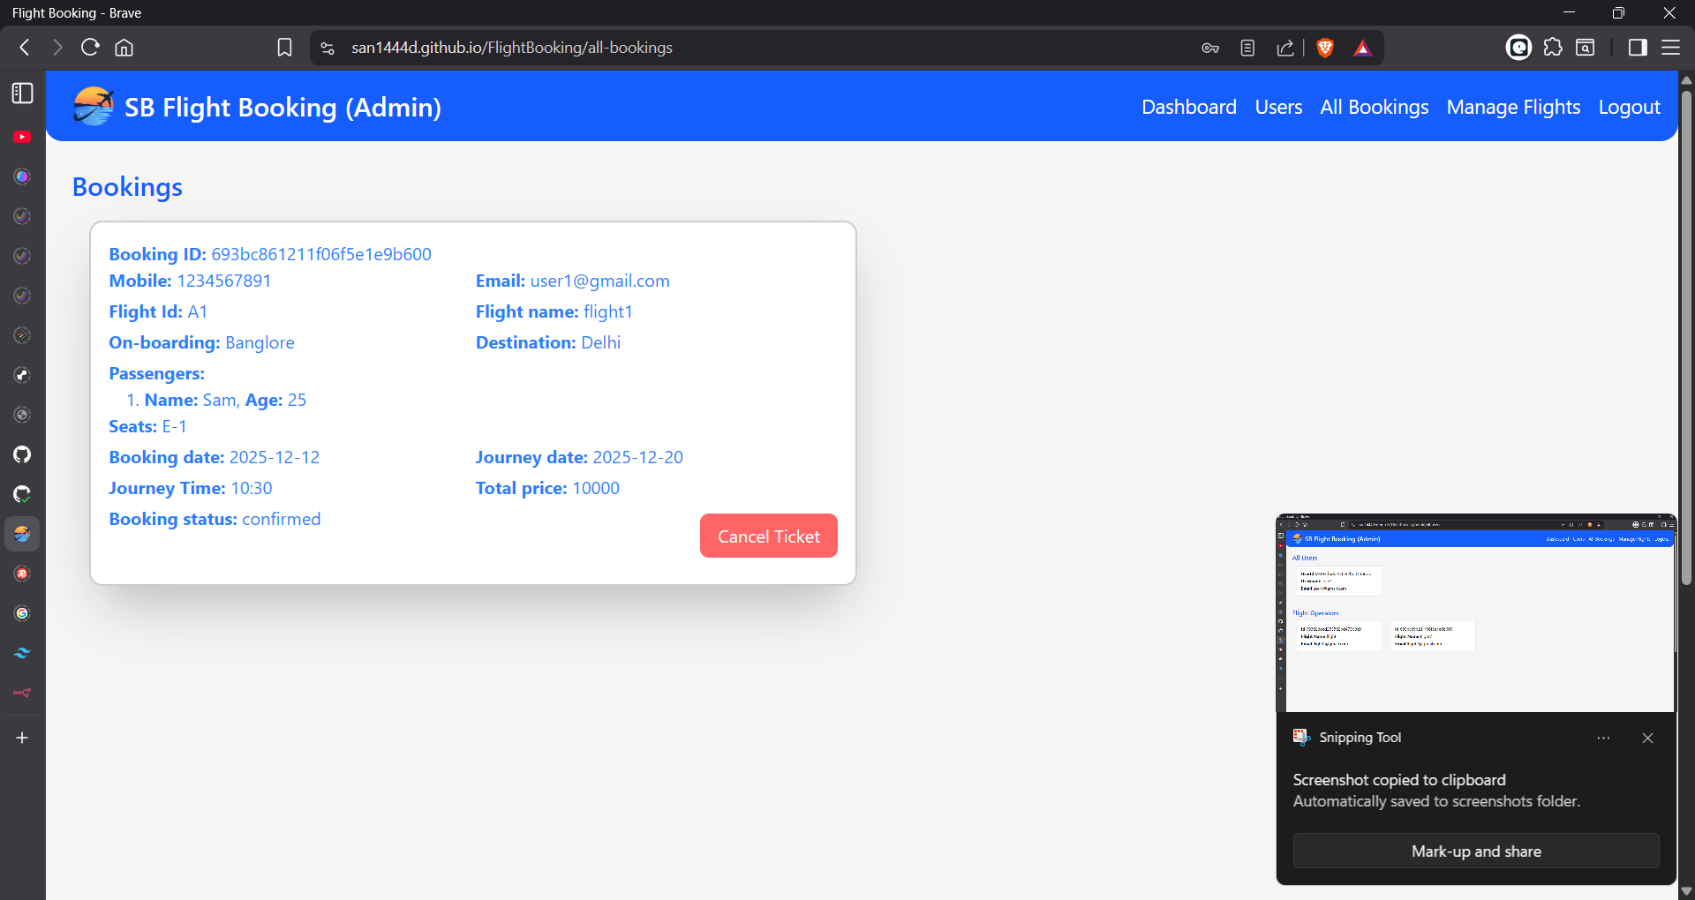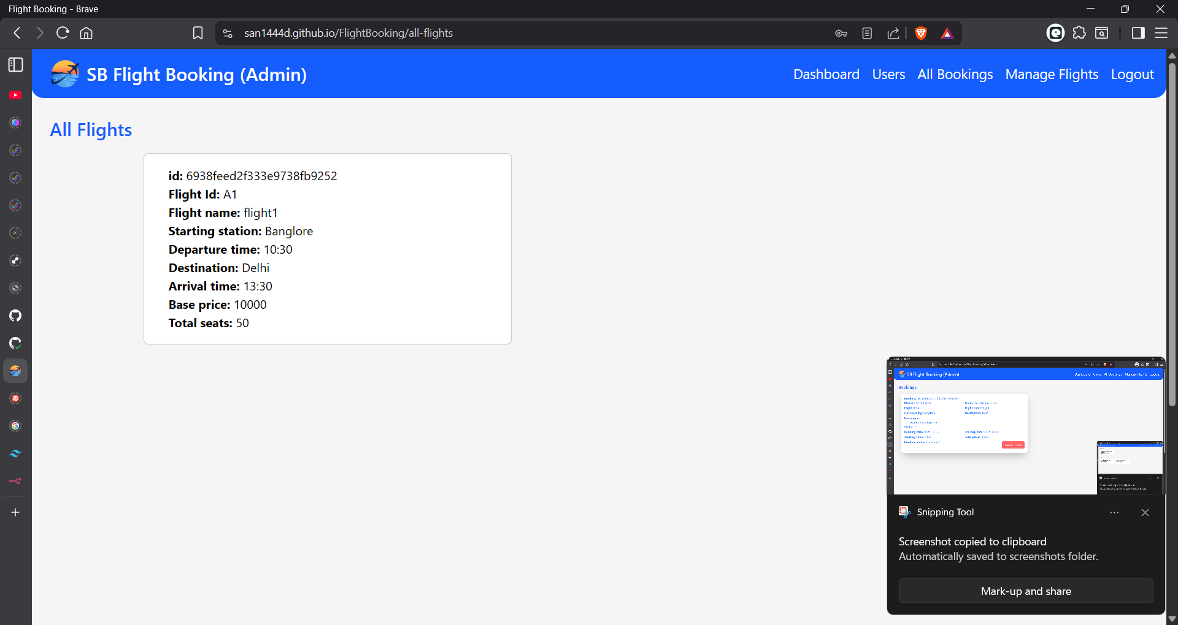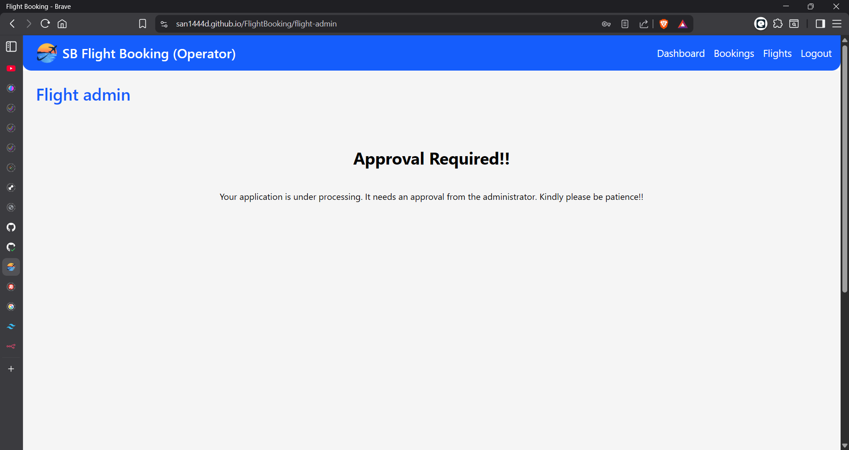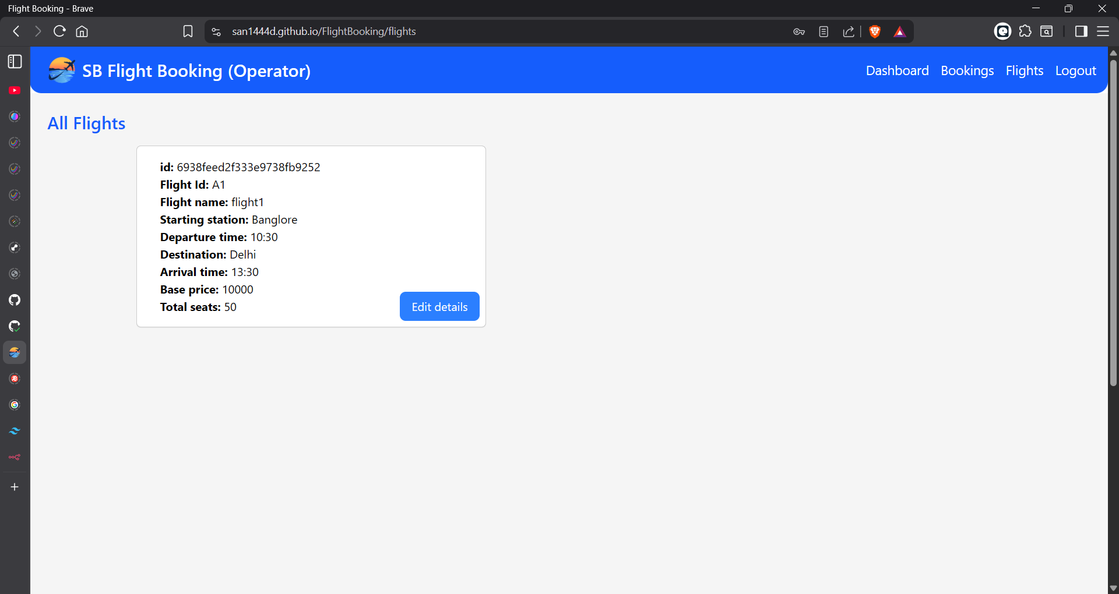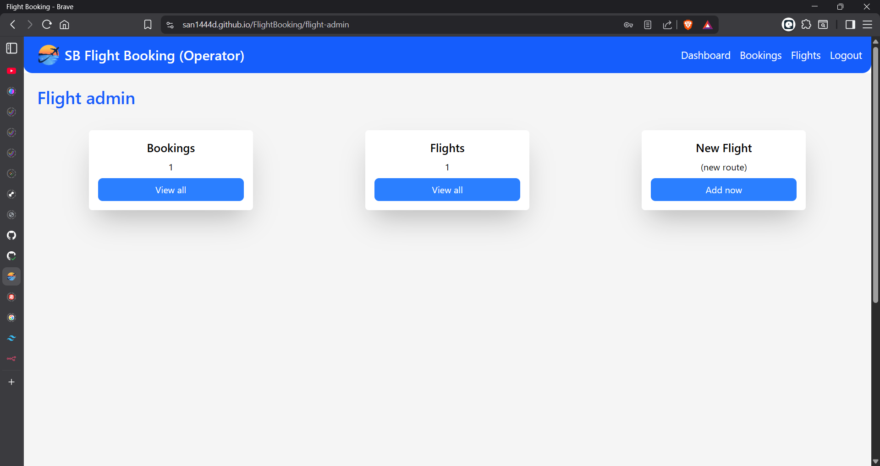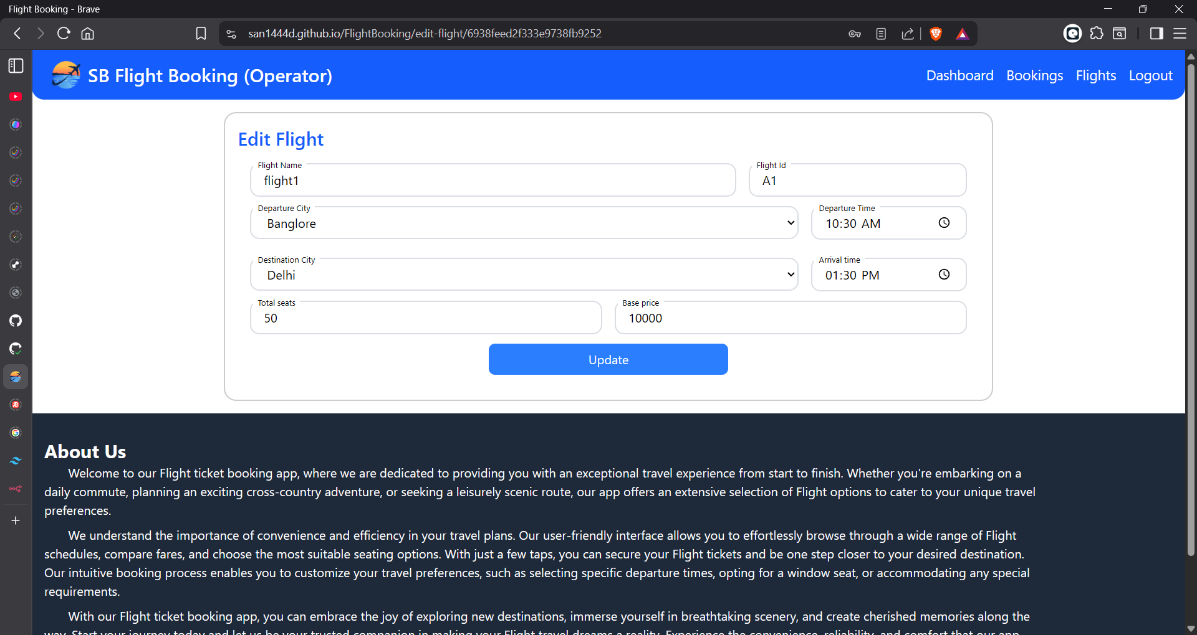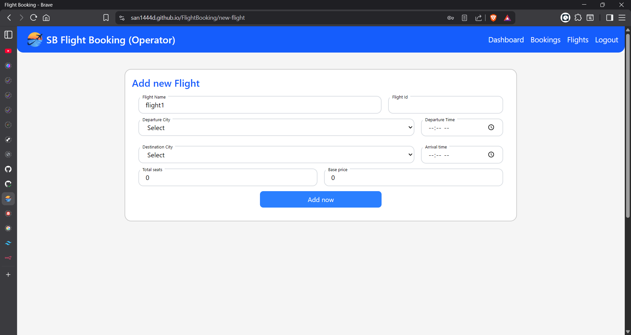

## 12. Known Issues

* Payment integration missing